# Nest a Subquery in FROM (Finalized)

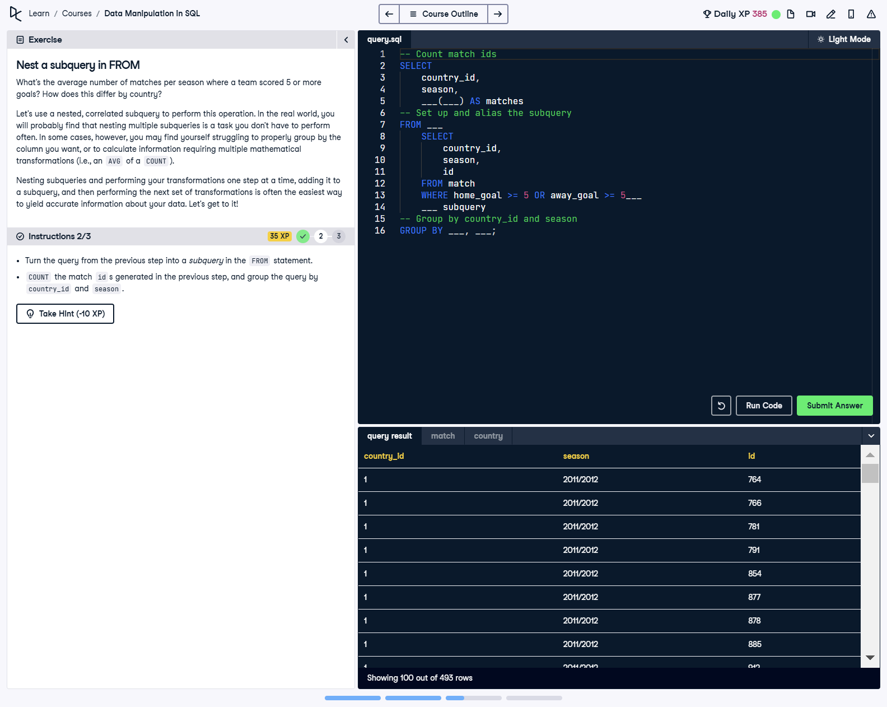

## Question

1. Create a subquery in the FROM clause that retrieves country_id, season, and id for matches where either the home or away team scored at least 5 goals.  
  
2. Use COUNT in the main query to aggregate the match IDs retrieved by the subquery.  
  
3. Group the results by country_id and season.

## Corrected Solution

SELECT  
 country_id,  
 season,  
 COUNT(id) AS matches  
FROM (  
 -- Start by setting up the subquery  
 SELECT  
 country_id,  
 season,  
 id  
 FROM match  
 WHERE home_goal >= 5 OR away_goal >= 5  
) AS subquery  
-- Count the match ids and group by country_id and season  
GROUP BY country_id, season;

## Explanation

This query calculates the number of matches in each country and season where at least one team scored 5 or more goals. The subquery isolates the relevant matches by filtering on the goal criteria and selecting the required columns. The main query aggregates the match counts using COUNT(id) and organizes the results by country and season with the GROUP BY clause.